**4**



**_ _ _ _**

**F P T G L A S U I Y R S**

**3**



**_ _ _ _**

**I V O T A S R P P U K Y**

**_ _ _ _ _ _ _ _**

**Q N R S L E X D I H R C**

2**2**



**_ _ _ _ _**

**H C V G D R E L R T I K**

**_ _ _ _ _ _ _ _**

**Q N R S L E X D I H R C**

1**1**



**_ _ _ _**

**Q A R S T E X D I H R C**

**8**



**_ _ _ _ _ _ _**

**I C Y R P E N F V G E E**

**7**



**_ _ _ _**

**N S F O K M J P Z I N R T**

**_ _ _ _ _ _ _ _**

**Q N R S L E X D I H R C**

**6**

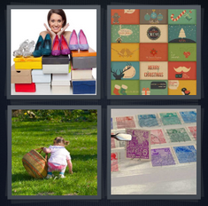

**_ _ _ _ _ _ _**

**C L S H E Z G T L I O C**

**5**

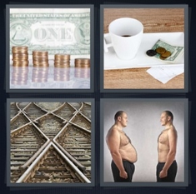

**_ _ _ _ _ _**

**G S P I M C H H N A R E**

1**10**



**_ _ _ _ _ _**

**R E P Y A E T R E Z G Y D**

9**9**

**_ _ _ _ _ _ _ _**

**P A R X C V E T R H E I K**

**12**

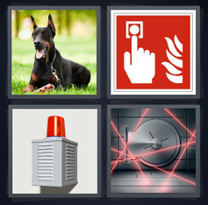

**_ _ _ _ _**

**N R A O Z T L R A Y M B**

**11**



**_ _ _ _ _**

**W R Q O U R T W I J O E**

**14**



**_ _ _ _ _ _**

**E S Y Q O P H J S E Z R**

**13**

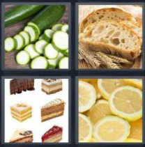

**_ _ _ _ _**

**P S C L C P G T L F E I**

**16**

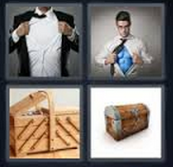

**_ _ _ _ _**

**H M C O X E A K S O D T**

**15**

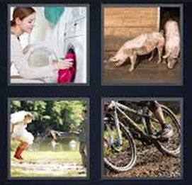

**_ _ _ _ _**

**T S I V D R D K Y U R C**

**20**

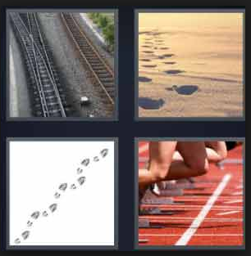

**_ _ _ _ _ _**

**J A J S M R Y Y C K R I T**

**19**



**_ _ _ _ _**

**T N U C R P S N R I A K**

**17**

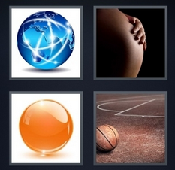

**_ _ _ _ _**

**D E R G W Z U S E N T O Z**

**18**

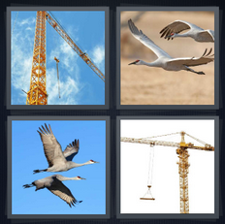

**_ _ _ _ _**

**S A Z C X R S T I N E X**